Temperature Sensors Test Report

# Test Components:

|  |  |  |
| --- | --- | --- |
| **Sensor Description** | **Part Number** | **Output Interface** |
| TI ±0.1°C Precision Analog Temperature Sensor | LMT70 | Analog (Voltage) |
| Microchip MCP9808 digital temperature sensor with ±0.5°C (max.) accuracy | MCP9808 | I2C upto 400KHz |
| TI digital humidity sensor with integrated temperature sensor  Relative Humidity Accuracy ±2% (typical)  Temperature Accuracy ±0.2°C (typical) | HDC1080 | I2C upto 400KHz |
| Silicon Labs digital humidity sensor with integrated temperature sensor  Relative Humidity Accuracy ±3% (typical)  Temperature Accuracy ±0.4°C (typical) | Si7021 | I2C upto 400KHz |

# Test on 5/11

## Task1:

Measure room temperature, which is set to 78**°**F (25.5**°**C). The LMT70 evaluation board and HDC1080 evaluation board are placed side by side on a desk facing up. The measurement screenshots are taken 15 min after the first measurement started.

Conclusion: The result from LMT70 is very close to the room temperature the set by the thermostat while the result from HDC1080 is about 1**°**C higher than expected room temperature.

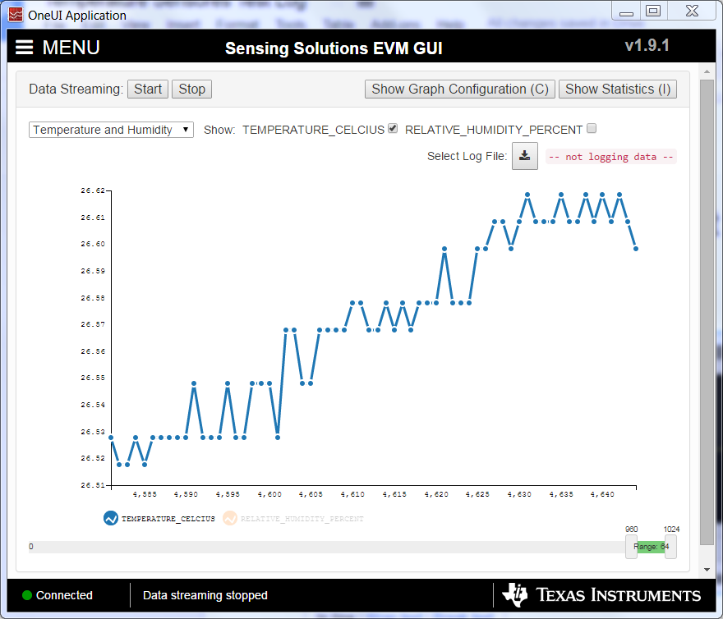

Figure : Test results of HDC1080

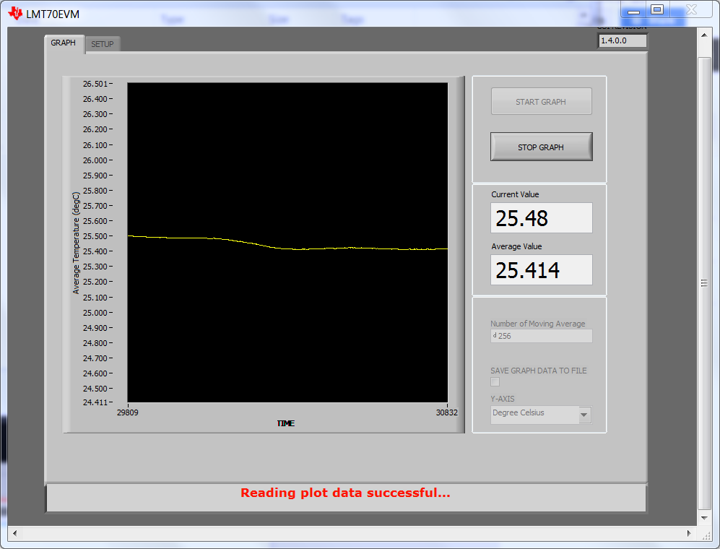

Figure : Test results of LMT70